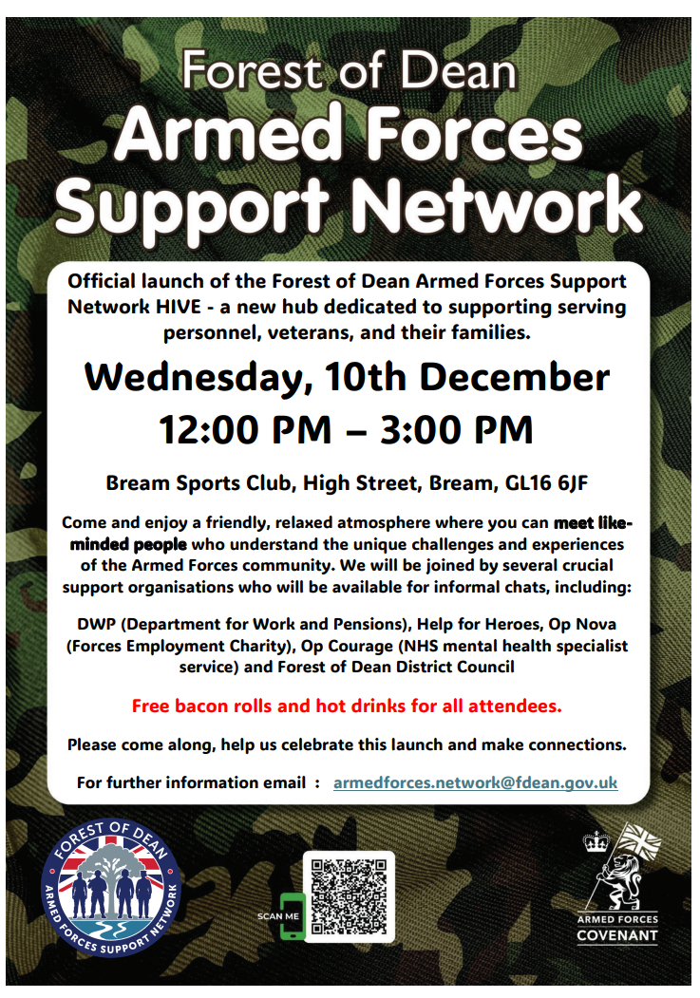
‘HIVE’ 2026 DATES
Supported by Military Charities including Op Nova, Help for Heroes and Op Courage. Cinderford RBL,
DWP, Community Wellbeing (FODDC),

Bream Sports Club, High Street, Bream, GL16 6JF

Wednesday, 7th January 12.00 – 15.00
Wednesday, 4th February 12.00-15.00
Wednesday, 4th March 12.00-15.00
Wednesday, 1st April 12.00-15.00
Free bacon rolls and hot drinks.
Come along and make connections.

